Project Design Phase-II
Technology Stack (Architecture & Stack)

Date | 05 July 2026
Team ID
Project Name | Personalised Networking Assistant
Maximum Marks | 4 Marks

Technical Architecture:
The Personalized Networking Assistant follows a client-server architecture built using Streamlit for the frontend and FastAPI for the backend. Users enter event details and personal interests through the Streamlit interface. The backend processes the input using KeyBERT with DistilBERT to extract keywords and generate personalized conversation topics. The generated content is then verified using the Wikipedia API for fact-checking. Finally, the application displays the conversation suggestions, verified information, and stores conversation history and user feedback in a JSON file for future reference.
Example: Order processing during pandemics for offline mode
Guidelines
The Personalized Networking Assistant uses a client-server architecture. The local infrastructure includes the Streamlit frontend, FastAPI backend, KeyBERT with DistilBERT, and JSON data storage. The cloud infrastructure includes the Hugging Face Model Hub and the Wikipedia API for fact-checking.

User input is processed to generate personalized conversation topics, verified using the Wikipedia API, and the results are stored and displayed to the user.

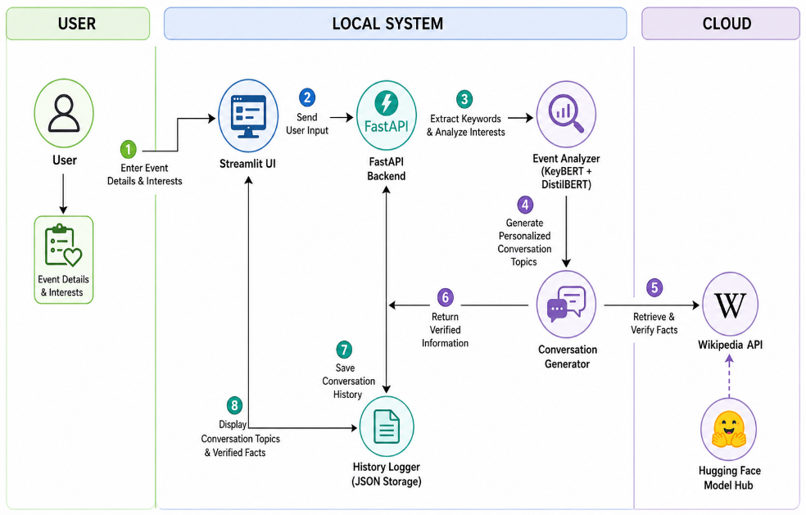
Table-1 : Components & Technologies:
S.No | Component | Description | Technology
 | User Interface | Interface for users to enter event details and view results | Streamlit
 | Application Logic-1 | Processes user requests and manages application workflow | FastAPI (Python)
 | Application Logic-2 | Analyzes event details and extracts keywords | KeyBERT + DistilBERT
 | Application Logic-3 | Generates personalized conversation topics and performs fact-checking | Python
 | Database | Stores conversation history and user feedback | JSON File
 | Cloud Service | Provides pre-trained language model | Hugging Face Model Hub
 | File Storage | Stores application data locally | Local File System
 | External API-1 | Verifies generated information | Wikipedia API
 | External API-2 | Not Used | —
 | Machine Learning Model | Keyword extraction for conversation generation | DistilBERT (via KeyBERT)
 | Infrastructure (Server / Cloud) | Local deployment with external cloud services | Local System + Cloud APIs

Table-2: Application Characteristics:
S.No | Characteristics | Description | Technology
 | Open-Source Frameworks | Open-source frameworks used for application development | Streamlit, FastAPI, KeyBERT, DistilBERT, Python
 | Security Implementations | Input validation and secure communication between application components | FastAPI Validation, HTTPS
 | Scalable Architecture | Modular client-server architecture supporting future enhancements | Streamlit, FastAPI
 | Availability | Application uses reliable cloud services for AI model and fact-checking | Hugging Face Model Hub, Wikipedia API
 | Performance | Fast request processing with lightweight backend and efficient AI models | FastAPI, KeyBERT, DistilBERT

